**Final Lab (Assignment)**

***(Show input and output side by side for all problems****)*

1. Apply Gaussian noise to Figure 1, and then use the following to restore the image:

i. Geometric Mean filter

ii. Harmonic Mean filter

iii. Contra-harmonic Mean filter

1. Apply Gaussian noise to Figure 1, and then use the following order statistic filters to restore the image:

i. Median filter

ii. Maximum filter

iii. Minimum filter

iv. Midpoint filter

v. Alpha-trimmed filter

vi. Trimmed filter

1. By observing and comparing each of the outputs, determine which filter restores the image closest to its original state. Mention the reasoning behind your observation and choose the most suitable image for the following problems.
2. Detect the tumor from the image from Problem 3 using the segmentation approaches listed below:

(***Outline the segmented object to highlight the tumor****. You can crop the image for accurate segmentation.*)

* + 1. Similarity approaches:

1. Local/Regional Thresholding
2. Global Thresholding
3. Variable Thresholding
4. Dynamic/Adaptive Thresholding
   * 1. Discontinuity approaches: Edge Detection (Sobel, Canny, Prewitt)
5. Show how the Similarity and Discontinuity techniques compare.

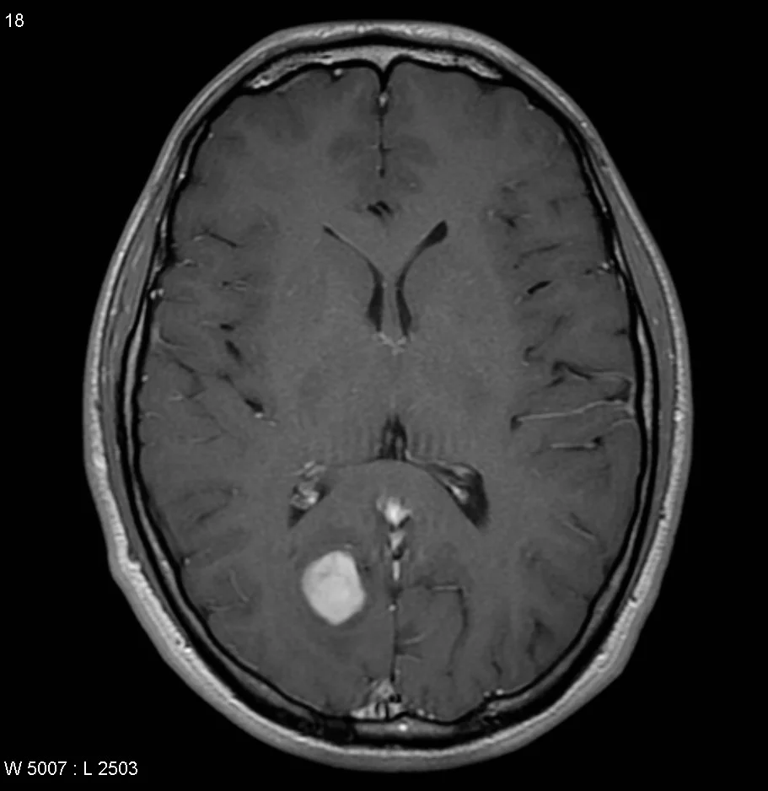

**Figure 1:** Tumor -1

1. Segment the tumor from Figure 2 by using:

i. Region growing approach

ii. Region Splitting and Merging approach

1. Segment the tumor from Figure 2 by using Marker Controlled Watershed segmentation.
2. Segment the tumor from Figure 2 by using Quadtree Segmentation.
3. Generate a binary mask of the tumor from Figure 2 using any segmentation method of your choice, then apply:

i. Morphological Dilation

ii. Morphological Erosion

By using appropriate structuring element on the mask.

**Figure 2:** Tumor-2

10. Apply the Hough transform to Figure 3 and draw the detected lines on the original image.

**Figure 3:** X-Ray Image